**AJIO CLONE WEBSITE – ADIO**

Customers can directly visit the site, choose the category and can order the dress they desire.

***Site Home-page :***

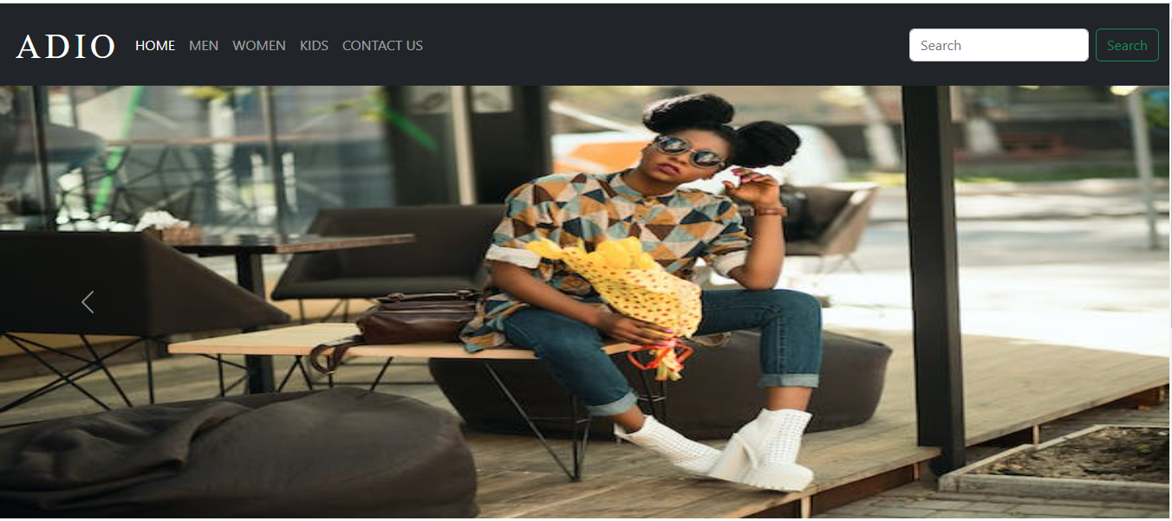

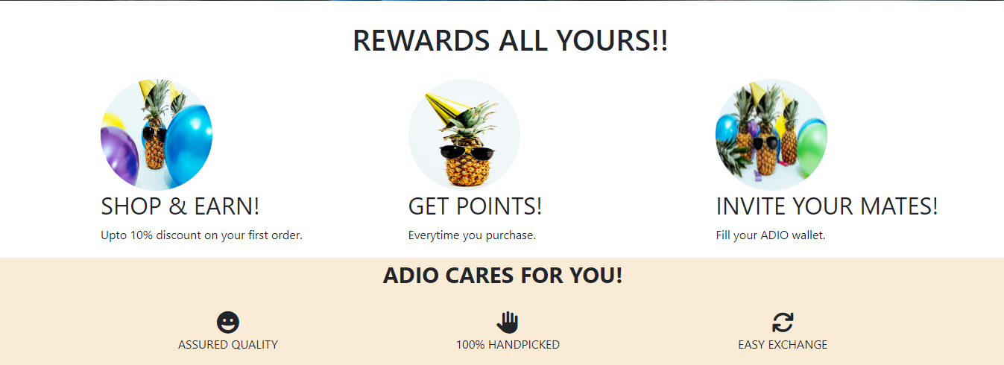

***Pages comprised-of :***

* Homepage
* Landing pages of chosen categories
  + Product Listing page
    - Product details page with payment gateway
      * Checkout page

***Site-flow :***

**1.1 *Home page* ->**

***Navigation bar section***

***Bootstrap Carousel section***

Footer content

***Footer section***

***Rewards / offers section***

Carousel comprises of 4 to 6 images with cross-fade effect using in-built bootstrap classes

SEARCH BUTTON

CATEGORY / LANDING PAGES

LOGO / BRAND NAME

**1.2 *Category / Landing page* ->**

***Navigation bar section***

Caption about the category chosen by the customer

Filter section based on **Prices**

Product image

Product brand name + Prices

Product image

Product brand name + Prices

***Products listed in grid format with brand’s name and prices.***

***Footer section***

**1.3 *Product description page* ->**

***Navigation bar section***

***Footer section***

Product description

Directed to Checkout section / payment gateway (built using bootstrap)

Customer reviews

About model and product

Product images